**Microprocessor Lab**

Laboratory Activity No. 2

**Arduino and Tinkercad Interface**

|  |
| --- |
|  |

Score

*Submitted by:*

**Sarita, Andrew Miguel P.**

**S, 10:00 AM – 1:00 PM / CPE 0412.1-1**

*Date Submitted*

**30-09-2023**

*Submitted to:*

**Engr. Maria Rizette H. Sayo**

I. Objectives

This laboratory activity aims to implement the principles and techniques of hardware programming using Arduino through:

- creating an Arduino programming and circuit diagram.

II. Method/s

- Perform a task problem given in the presentation.

- Write a code and perform an Arduino circuit diagram of a ring counter that display

eight (8)LEDs starting from left.

III. Results

**TinkerCad**

**Exercise 1: Write a code that does a ring counter display for eight (8) LEDs starting from left.**

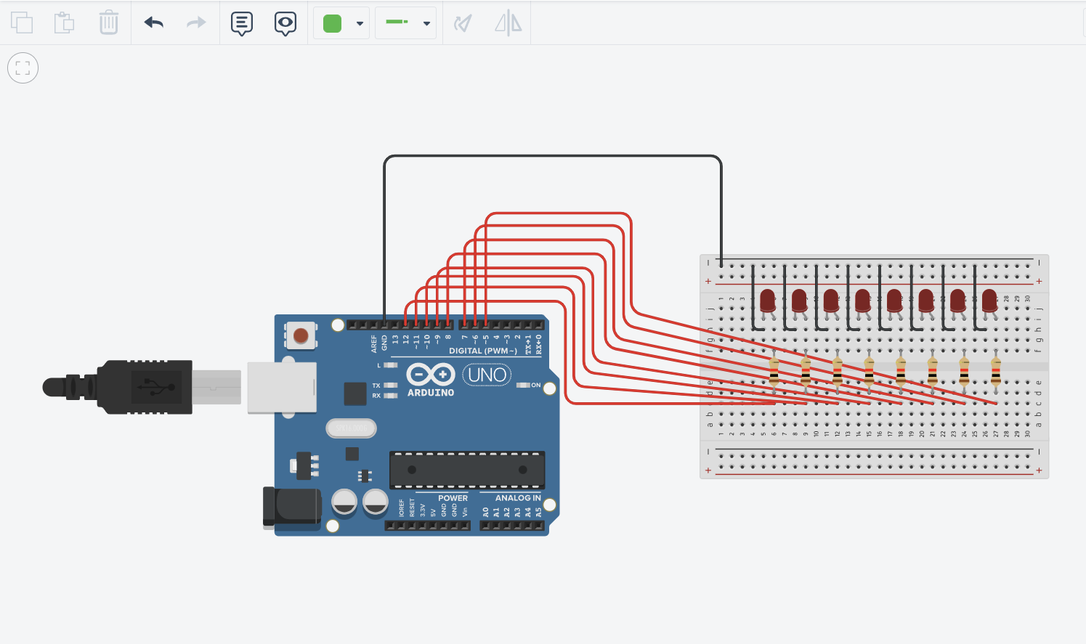

Figure No.1 Ring Counter Display Circuit Diagram

**Components Used**

1. 8 LEDs
2. Resistor
3. Breadboard

**CODE:**

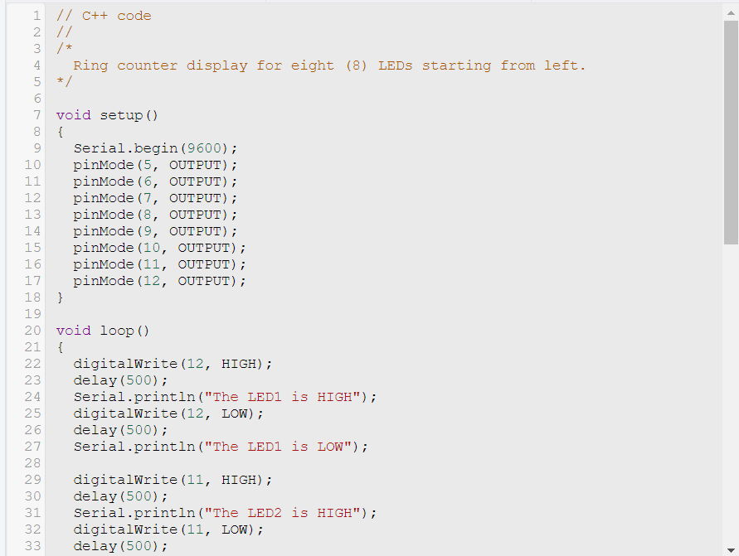

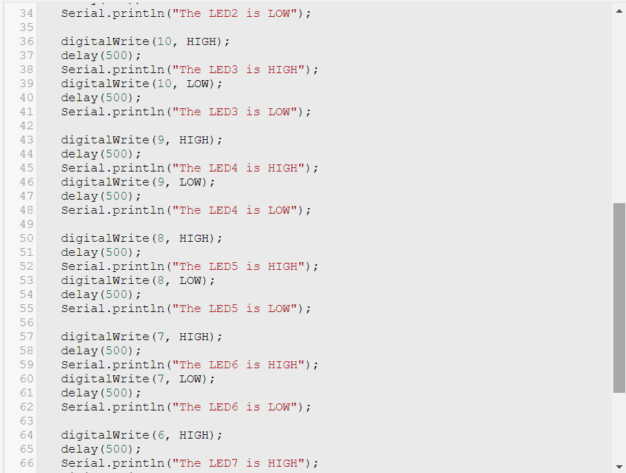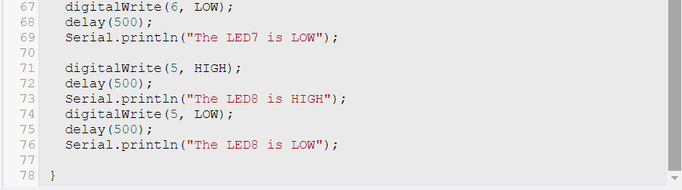

Images from Simulation (in sequence):

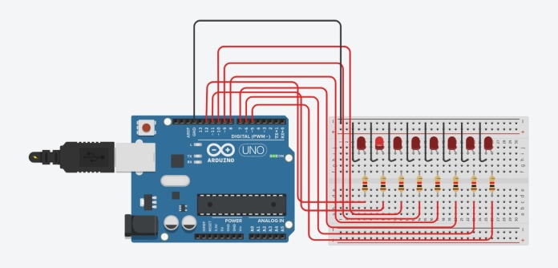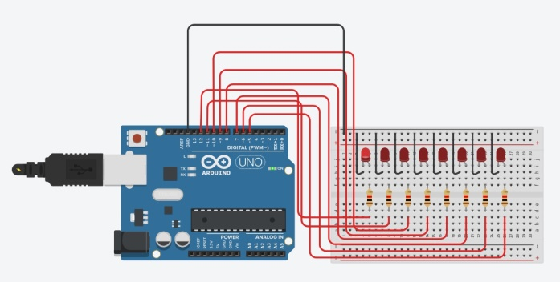

Lighting of LED 1 Lighting of LED 2

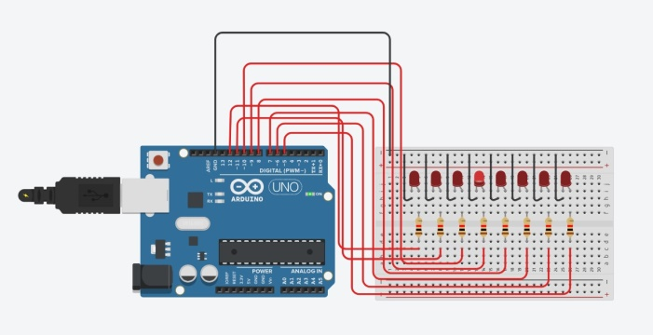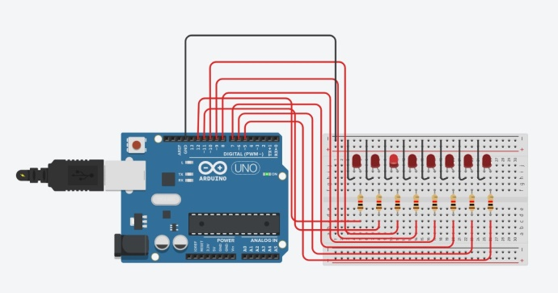

Lighting of LED 3 Lighting of LED 4

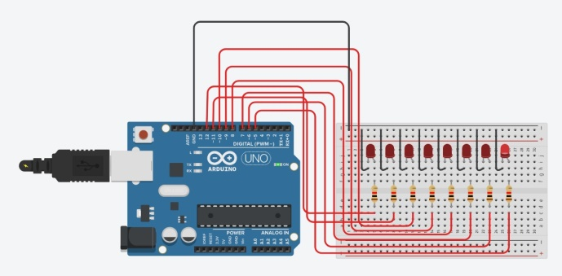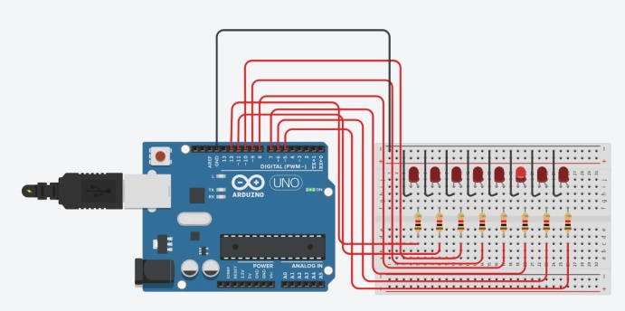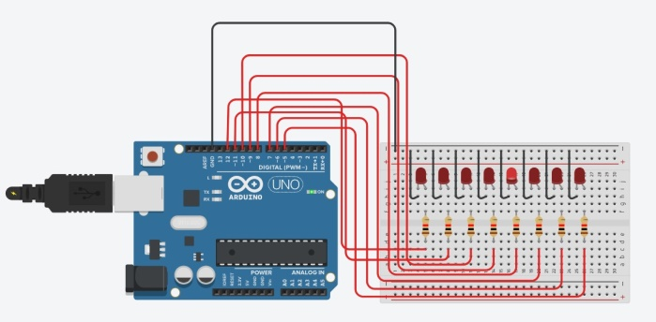 Lighting of LED 5 Lighting of LED 6

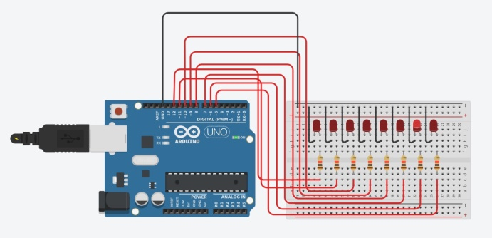 Lighting of LED 7 Lighting of LED 8

IV. Conclusion

In digital logic, ring counters are one of the common types of shift register counters. These are shift registers with the serial output linked back to the serial input. They are categorized as counters since its operation includes a specified sequence of states. Ring counters, on the other hand, exhibits one flip-flop stage for each state in the sequence. Thus, the unique attribute of ring counters is that the output of the last flip-flop is linked to the input of the first flip-flop.

This laboratory activity aims to examine this concept through its application in a circuit. The materials that were used include a breadboard, resistors, 8 LED diodes, and the Arduino Uno R3. The Arduino Uno R3 was used to for the input and output pins connected to the LED diodes and for the uploading of the program which will be implemented on the circuit design. The circuit diagram and the source code of the Arduino program for this activity are both provided in the initial segment of the paper.

All in all, this laboratory activity enabled the author to construct a ring counter display circuit involving a breadboard, LED diodes, resistors, and the Arduino Uno. The circuit constructed matched the design provided at the first segment of the paper, as seen in the images gathered from simulation. The LED diodes turned on sequentially, which exhibited the concept of ring counters. Images obtained from the simulation that can be perceived from the previous section indicate the lighting of each LED diode, which is presented in an order of their display. Lastly, a delay of 500 milliseconds was set in each LED display for clear observation of the LED lighting process.

**References**

[1] A. Tan, “Lecture 13: Sequential Logic Counters and Registers,” Methodist College of Engineering and Technology. <https://methodist.edu.in/web/uploads/files/counters_and_registers_5.ppt>

[2] A. K. Alaloosy, “Ch. 9-2 Shift Registers,” University of Anbar. <https://www.uoanbar.edu.iq/eStoreImages/Bank/5817.pdf>